* Intro to Linux

***what is Operating System***

OS is a Mediator between application and hardware

* it provide environment to run services
* it provide platform to run application
* It manages hardware
* It is a set of Program (It converts High level language to low level language)

->High level language: human readable language (ex. Python, java, etc)

->Low level/Machine language: in the form of 0’s and 1’s(binary)

OS

user ------------------------> computer

( interface/mediator )

History of linux

Linux is a kernel and it was written by Linus Torvalds in 1991

kernel + SOFTWARE = OS

(linux) (GNU) (LINUX)

GNU-->The GNU project is **a mass collaborative initiative for the development of free software**. founded by the Richard Stallman

***What is Linux?***

Linux an [open source](https://www.redhat.com/en/topics/open-source/what-is-open-source) operating system (OS). An [operating system](https://www.redhat.com/en/technologies/linux-platforms/old-enterprise-linux) is the software that directly manages a system’s hardware and resources, like CPU, memory, and [storage](https://www.redhat.com/en/topics/data-storage/software-defined-storage)*.*

Open Source - Linux source code is freely available which means anyone can modify this code and create new version and it is community based development project. Multiple Teams works in collaboration to enhance the capability of Linux operating system

***Architecture of Linux***

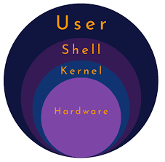

* Linux architecture has four main components hardware,kernel,shell and user/application
* **Hardware :** it consists of motherboard ,CPU,HDD etc
* **Kernel :** kernel is the heart/core of the OS, kernel communicates with
* Hardware,It converts High level language to low level language
* **Shell :** provides interface to user to communicate with kernel
* **Application/user :** user interact with system via applications or

commands

***differences between windows and linux ?***

Windows:

1.user friendly

2.licensed required {closed source-Microsoft }

3.requirement of hardware is more

4.single user

5.easily attacked by virus

6.low security

7.ram consumption high

8.FAT & NTFS file system

9.used in server and client machine

Linux:

1. not user friendly (command based ,skilled person required)

2. open source----anyone can develop

3. licence not required.

4. less requirement of hardware.

5. multiple users are allowed.(6 users can allowed on terminal)

6. highly secured .

7. ram consumption low

8. file system EXT & XFS

9. nearly 80% of Servers linux based

***Que. Explain the FEATURES of Linux***

1) Open source

2)secure

3)easy installation

4)light weight

5)multiuser

6)multiple distribution

7)portable

8)difficult to use

9)low hardware requirement

***Various Distributions /Versions /Flavors of Linux***

as Linux is open source OS therefore its source code is accessible to general public hence anyone can modify the source code and create a new version of OS

* RHEL(Red hat enterprise Linux)
* FEDORA
* DEBIAN
* UBUNTU
* KALI
* AMAZON LINUX
* CENTOS

***Types of Users are there in linux***

There are Three types of users in linux Local user, root and system user

* $ local user ->has limited privileges
* # root user or super user/administrator->has all the privileges
* system user -->automatically generated by system for a specific

purpose or software.

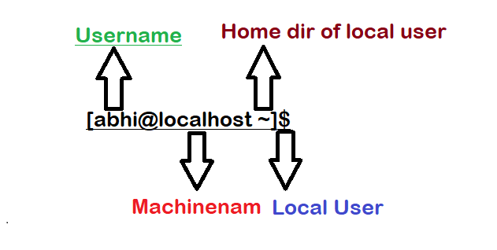

------------------------------------------------------------------------------------------

* Basic commands
* whoami -->shows username
* who -->shows username with terminal, date and time
* ls --> list
* ls -l / ll --->longlist,check list along with permissions
* cd --> change directory
* man <command > -->shows manual page of command
* info <command> -->same as man command
* <command> --help --> shows options

------------------------------------------------------------------------------------------

* su root -->switch to root user
* sudo -i -->switch to root user
* sudo - root -->switch to root user
* su - username -->switch to another user
* exit -->logout from current user

----------------------------------------------------------------------------------------

* hostnamectl -->shows machine information like OS and kernel

version etc

* hostname -->shows machine name
* hostname newhostname -->temporary change the hostname

->bash -->to save the changes made

* vi/etc/hostname -->permanently change the host-name
* cat /etc/os-release -->to check os version
* uname -->shows os name
* uname -a -->print system information like OS name, version,

date etc

* dmidecode -->shows hardware info[user must have root

permissions to run this command]

* free -h --> shows available memory [human readable]

***Directory structure in linux***

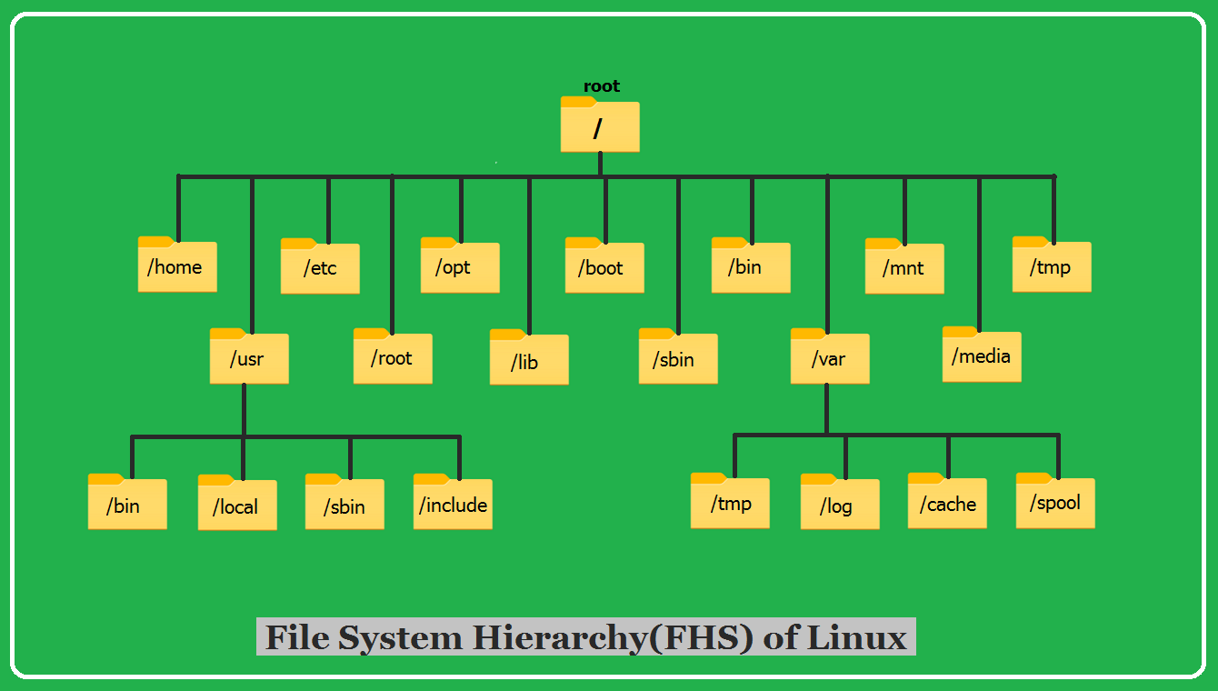

***Directory structure in linux***

Root /

* first directory in structure
* Every files and directory starts from the root directory.
* Only the root user of the system has the right to write under the root (/) directory.

*One another directory with name root is under

the root directory (/root) is the home directory of

the root user.

1)/bin  – local user's Binary files[not human readable]

2)/boot  –It stores all information about boot loader.Kernel initd, grub files are located into /boot directory.

3)/dev  – [Device Files] It includes terminal devices, USB, or any

device attached to the system. ex./dev/tty1, /dev/usb

4)/etc  – System and program configuration files

5)/home – It contains the user’s home directories,

personal files, user’s personal settings, etc.

ex. /home/abhi

6)/lib &/lib64 – [Shared Libraries] It stores libraries essential files for the binaries in /bin and /sbin.

7)/media – It is temporary mount point for removable device such as /media/cdrom, /media/floppy

8)/mnt  – It is for a temporarily mounting filesystem, where system admin can mount a file system

9)/opt  –used for optiona application software packages

10)/root -it is the home directory of the root user.

11)/run -it stores data that can give you an idea of how system resources are being utilized since startup

12)/sbin  – Root user's binary files,

It stores system related binaries executable. ex.ifconfig

13)/srv  –service

it contains server specific services related data

14)/sys - it contains information about various system components and drivers

15)/tmp  – It stores files which are created by system or user for a temporary purpose.

16)/usr  – [bin, sbin] It contains libraries, binaries, documentation, and source code

17)/var - varible

Stores files whose content is expected to change continuously ex. log files, spool files and cache files.

18)/proc  –stores information about system process information

ex. w, top, uptime